Name of Event: Department Internal Smart India Hackathon 2025
Description: The Department of Computer Science in association with ACM Student Chapter has successfully organized the Department Internal Smart India Hackathon (SIH) 2025 on 10th September 2025. The event served as a platform for students to showcase their innovative solutions to real-world problems and to prepare for the upcoming Smart India Hackathon at the national level. Each team worked under the guidance of faculty coordinators and mentors to present innovative solutions. The evaluation was conducted by the departmental panel members as per the guidelines of SIH. The internal hackathon helped in shortlisting potential teams for further stages of the Smart India Hackathon. It also provided students with a hands-on experience of teamwork, time management, and innovation-driven development.
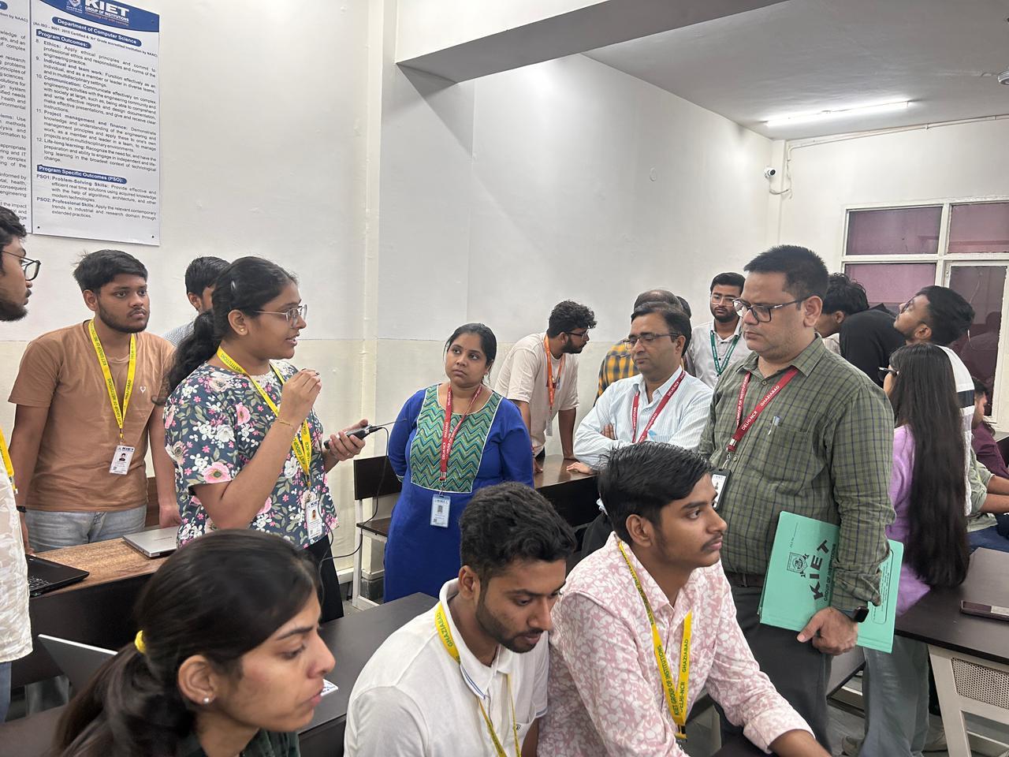

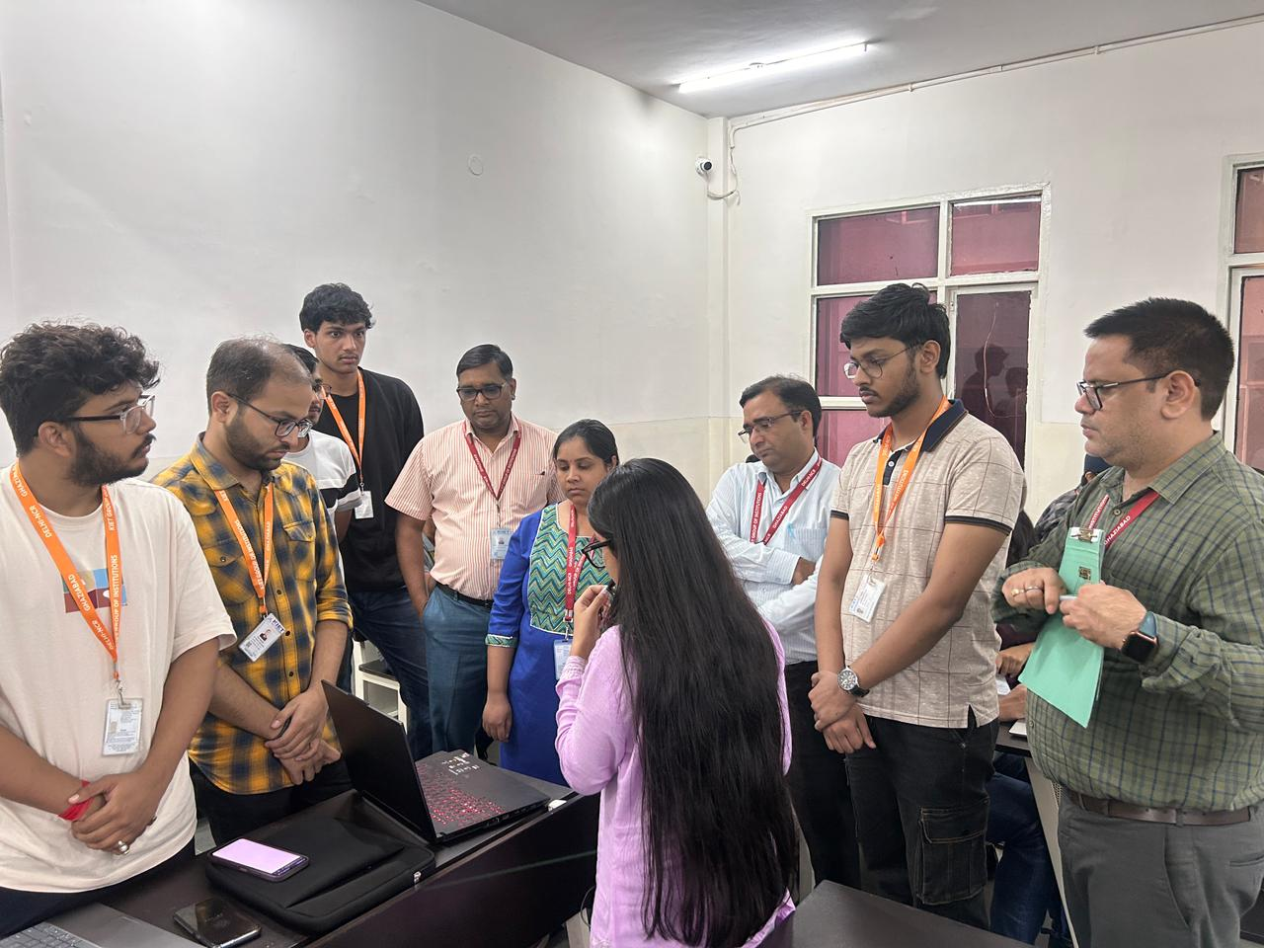
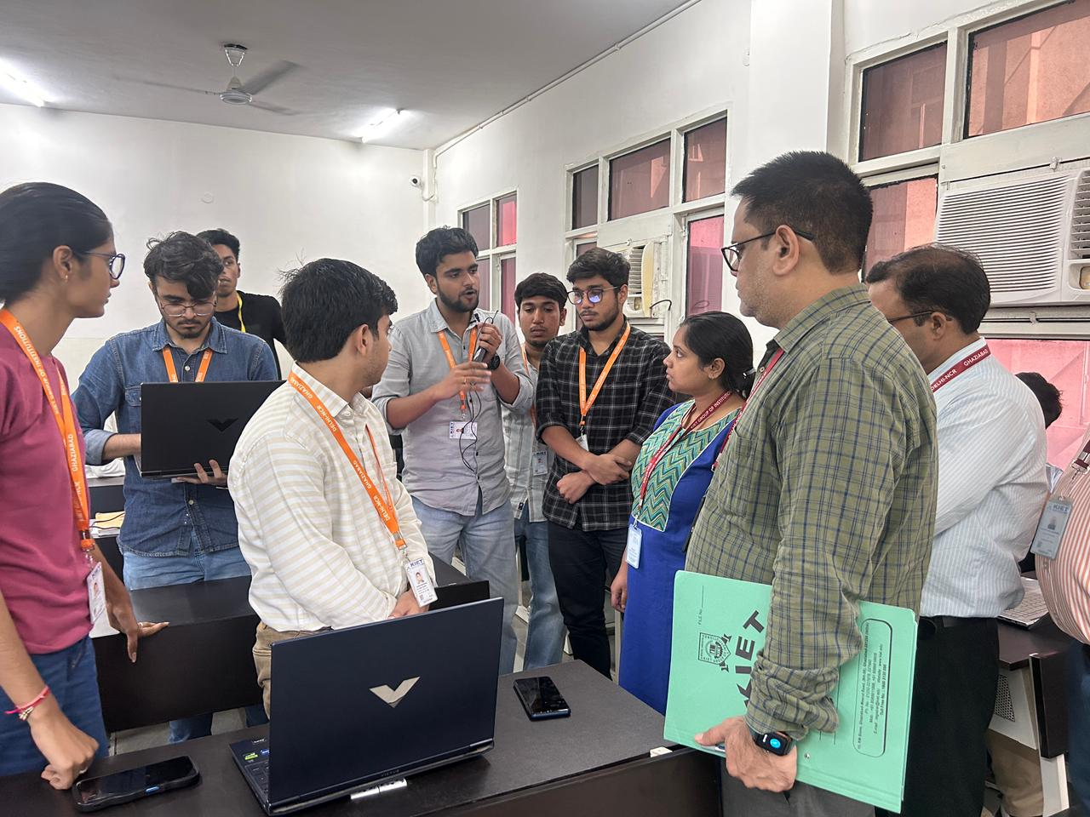
Name of Event: Quantum–Cyber Convergence 2025
Description: The Quantum–Cyber Convergence 2025 hosted by Department of Computer Science gave students a solid foundation in quantum computing, from basic principles (qubits, superposition, entanglement) to mathematical prerequisites and real-world applications in its first session on “The Entangled Future: How Quantum Computing Will Connect Everything” on 23th September-2025 from 10:50 A.M – 12:50 PM for CS 2nd year and 3rd year students by Dr. Pawan Singh Mehra. Most participants felt motivated and inspired to explore the field further, and many walked away with career direction and awareness of quantum’s impact on AI and cybersecurity.
The next session was on the topic “Latest Trends in Cyber Security” in KSOP Conference Hall on 23th September-2025 from 02:00 P.M – 04:00 PM for CS 2nd year and 3rd year students by Mr. Vishwameet Chawla. The session started with a broad introduction, moved into how cybersecurity and AI are connected, provided real-world examples and best practices, touched on careers, and concluded with a forward-looking view on quantum cybersecurity.
Students overwhelmingly rated the speaker highly, describing the session as insightful, informative, and motivating.
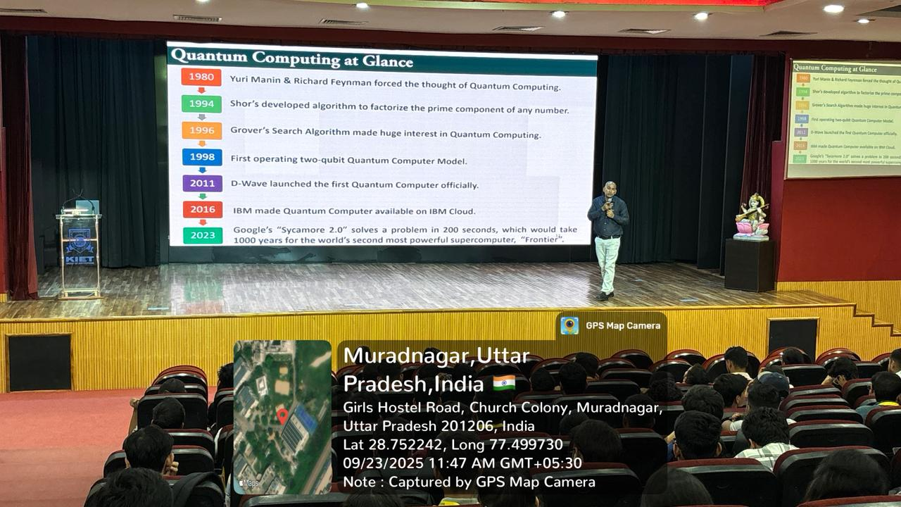
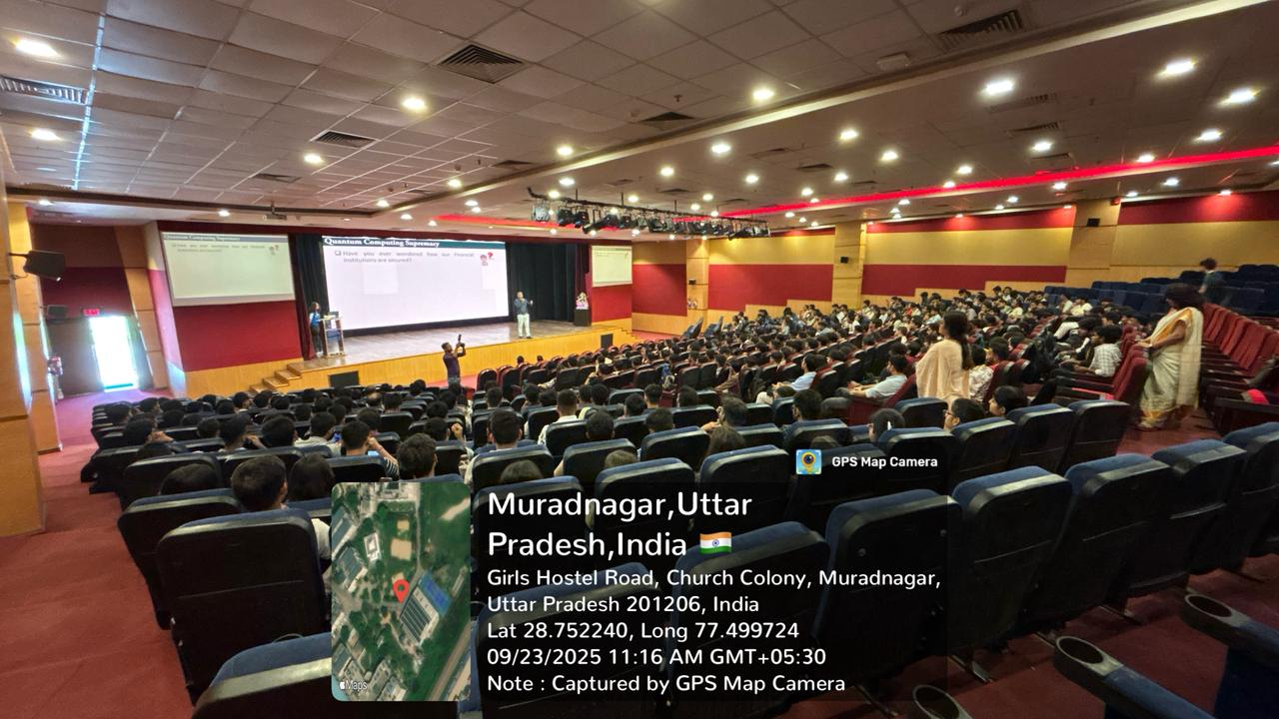
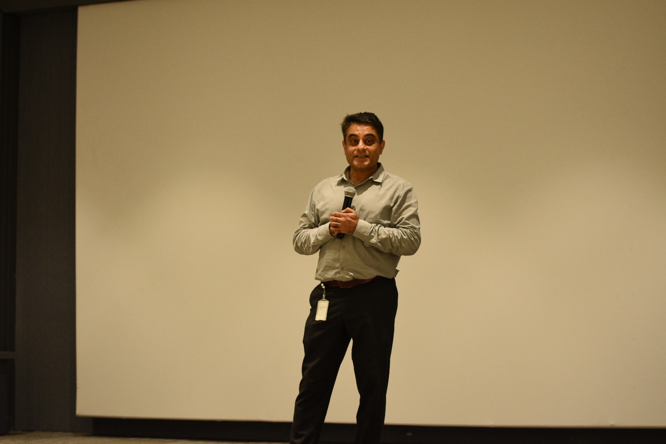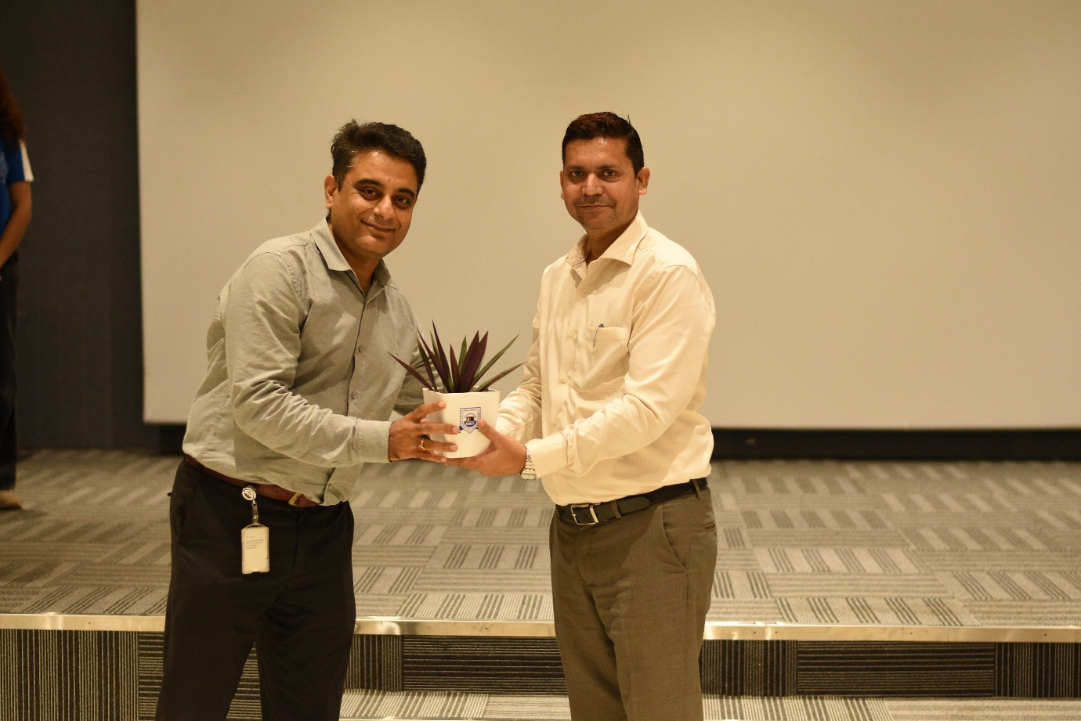

Name of Event– DATAVERSE 2025
Description: The event was hosted by Department of Computer Science on 06-07 November 2025 with Tag Line: “Code. Create. Conquer the DataVerse” and theme “Data Science and AI Innovations”. A total of 158 teams participated in the online preliminary round conducted via the Unstop platform. Based on evaluation criteria focused on Data Science and Artificial Intelligence innovation, 96 teams were shortlisted for the offline round at the KIET campus.
Out of these, 70 teams reported on campus and participated in the offline competition.
DAY 1 – November 6, 2025
Event:Hackathon Round 1 Presentation
Time: 09:30 am to 3:30 pm
Round 1 Presentations (Morning Session)
- Teams present their ideas before their assigned panels.
- Each team delivers a short pitch followed by a Q&A with the expert jury.
- Remaining teams complete their presentations post-lunch.
- Jury members evaluate based on innovation, technical feasibility, and presentation clarity.
Announcement of Finalists
- Scores are compiled across all panels.
The Top 10 teams are shortlisted for Hackathon Round 2 (Offline Round) on November 7, 2025

DAY 2 – November 7, 2025
Event:
- Keynote sessions by 4 Renowned Speakers
    - Ms. Maya Sherman – AI Expert, Global Partnership on AI (Israeli Embassy in India).
    - Mr. Himanshu Joshi – Program Director, NITI Aayog.
    - Mr. Tarak Prabhakar – Founder Director & Strategic Industry Mentor, NextGen Technologies.
    - Mr. Ashwani Yadav – Founder & CEO, NeuroDrishti.

- Hackathon Round 2 Presentations
The winners were felicitated by Dr. Adesh Pandey (Director-Academics) and Dr. Ajay Kumar Shrivastava (Dean, CS) along with other guests. The top three winning teams received both monetary rewards and special recognition items. The Comrades, Orbyte, and Hackbros teams were awarded trophies, certificates, and exclusive goodies, along with cash prizes of ₹15,000, ₹10,000, and ₹7,000 respectively. The Kasukabe Coders and The Almighty teams, securing fourth and fifth places, were also acknowledged for their efforts with certificates and sponsored goodies. Every participant received a certificate, ensuring that all contributions to the event were recognized and celebrated. ACIENT AI gave premium subscription to top ten teams till 31st January 2026 for their platform. Unstop provided many goodies for the winners.
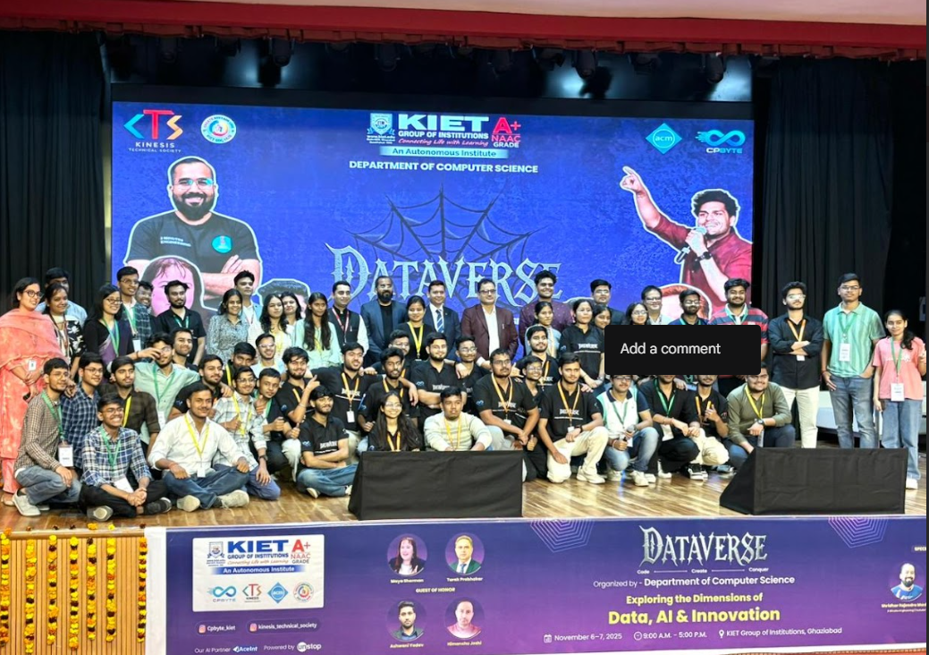

Name of Event: AI-Agents Exhibition
Description: The Department of Computer Science organized an AI-Agent Exhibition featuring the creativity and technical prowess of 2nd-year students. The event aimed to encourage hands-on learning and innovation in the field of Artificial Intelligence and Multi-Agent Systems.

A total of 52 enthusiastic teams participated in the preliminary round, each presenting unique problem statements and intelligent solutions. Based on innovation, implementation quality, and conceptual clarity, 40 teams advanced to the second round. The final round witnessed an impressive display of talent from 35 finalist teams, who showcased fully functional multi-agent systems addressing diverse real-world applications — from ai based car, smart traffic control, warehouse automation, and healthcare management to collaborative robotics and environmental monitoring.
